Thursday, Mar 08, 2022

Hanyu Gao

Proposal 0

Topic: Sponge City Program (SCP) Planning Enhancement Modelling integrated with social factors

Motivation

As one of the biggest top-down national policy in China, Sponge City Practice has been initiated in over 30 citied and invested over billions of dollars. However, after over seven years of practice, many cities in China are still suffering from severe water logging. Especially Zhengzhou, Henan, who has spent more than $80 million in SCP since 2016, was overwhelmed by record-breaking flooding in July this year. It caused 53.2 billion yuan (about $8.38 billion) in economic losses and took 292 lives. The effectiveness and practice of SCP are facing unprecedented challenges and doubts. It is a wake-up call for us and an important question raised worth introspecting on —how can we improve the SCP in this situation and make it more effective?

My project aims to both answer questions and solve tasks —

* How to improve the SCP planning and bring the social factors to the system?
  1. How to differentiate the nuance among the neighborhood and guide the SCP planning accordingly?
  2. How can we prioritize the most at-risk neighborhood in consideration of social factors?
* What is the appropriate and optimal combination of SCP facilities in different type of neighborhood? And what will the performance be to the vulnerable neighborhood?

Summary of Existing Relevant Research

According to overall **SCP** special planning, there are three key indicators:

1. **Volume capture ratio of annual rainfall (>75%)**
2. **Volume capture ratio of annual urban diffuse pollution (>50%)**
3. **The ratio of rainwater resource utilization (>5%)**

Under overall key indicators, there are four individual indicators for blocks in detailed planning:

1. **Sunken green space rate and Sinking depth**
2. **Permeable pavement rate**
3. **Green roof rate**
4. **Other**

Dataset identified

* Census Data of China (6th)
* <http://www.geodoi.ac.cn/webcn/doi.aspx?Id=131>
* Sentinel 2
* Global landcover dataset（GlobelLand30）
* Rainfall map

Summary of Methods

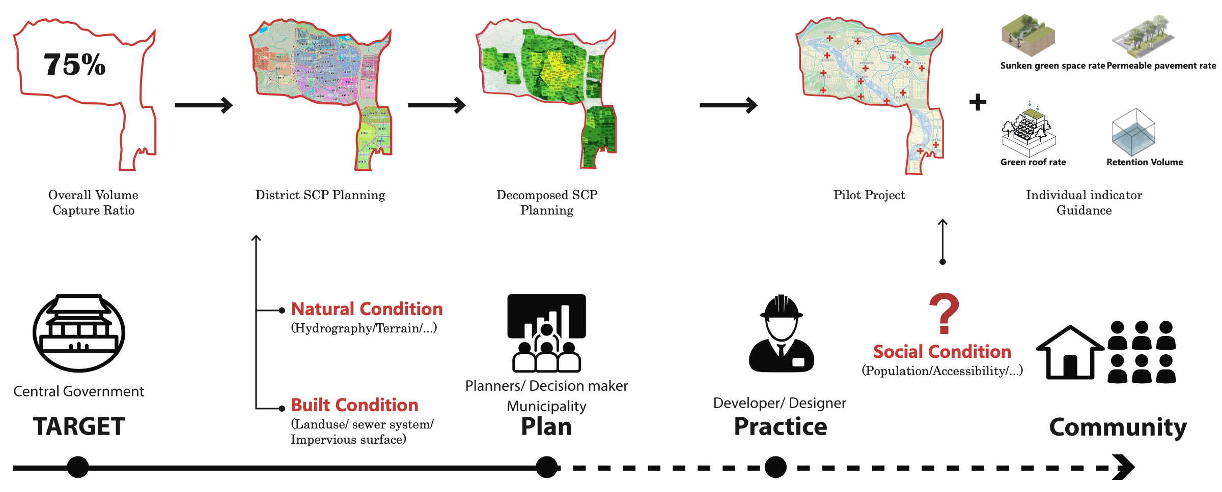

(*Existing Sponge City planning from Municipality document)

Gap:

As one of the biggest top-down national policy in China, current SCP program is a linear process led by central government and municipalities. The rainfall capture ratio target is leading the indicator decomposition and decide the funding plan. However, there is a huge gap between on-site practice and the community. Current planning is primarily based on natural condition and built condition, while social condition is mostly neglected. The impact on community is not well evaluated and it is hard to effect decision.

Therefore, it is essential to build up a social catchment typology system in SCP practice. As a result, we can generate the Sponge city practice approach in different scenario taking social factors into account.

To achieve this goal, it is of the essence to decide the index of social indicators determining the social catchment area. A catchment area, in human geography, is the area from which a location, such as a city, service or institution, attracts a population that uses its services and economic opportunities.[1] After considering the history context and social condition of Zhengzhou and limitation of existing dataset, I chose five factors to define the social catchment. They are housing price, population distribution, cultural assets, accessibility, and school district.

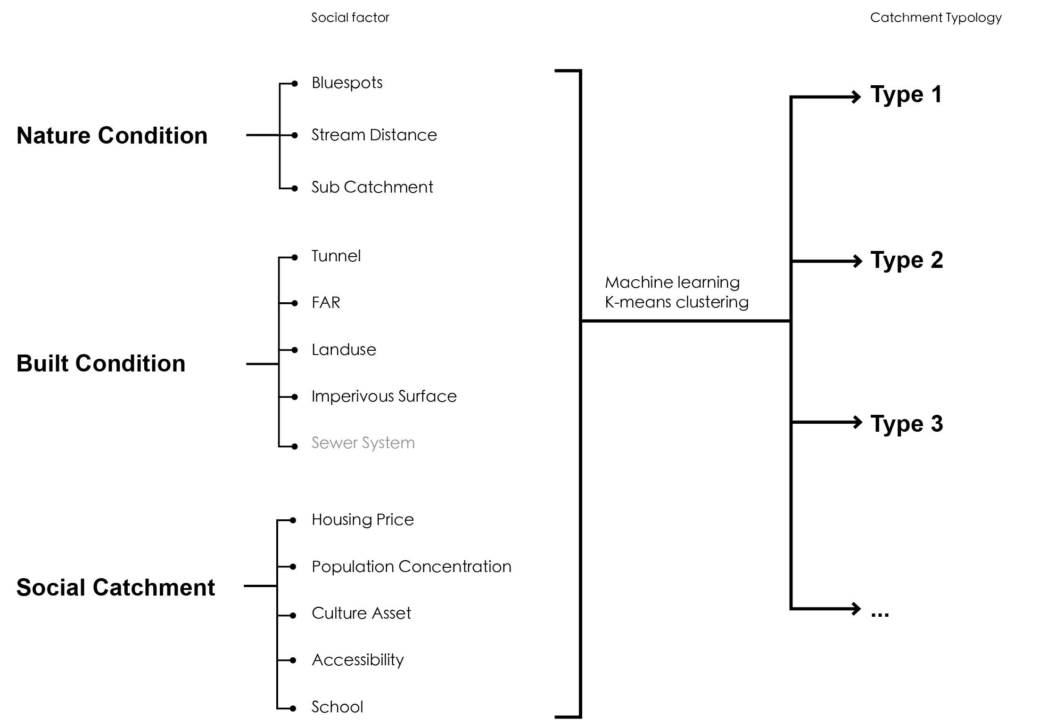

With the catchment typology system, I would summarize the feature of each type of neighborhood and create the prioritization based on designer’s knowledge and provide the combination of sponge city facility for different scenario.

Deliverable

* Indicator and SCP performance analysis: it will include write-up including charts, methodology diagrams, and analysis process.
* Based on the indicator analysis between SCP facilities and neighborhood features, I would propose an interactive parametric tool (ideally) to represent how the combination of SCP facilities effect the urban resilience and neighborhood benefits. It will include data visualization and 2d/3d modeling.

Data Summary

**Data Collection:**

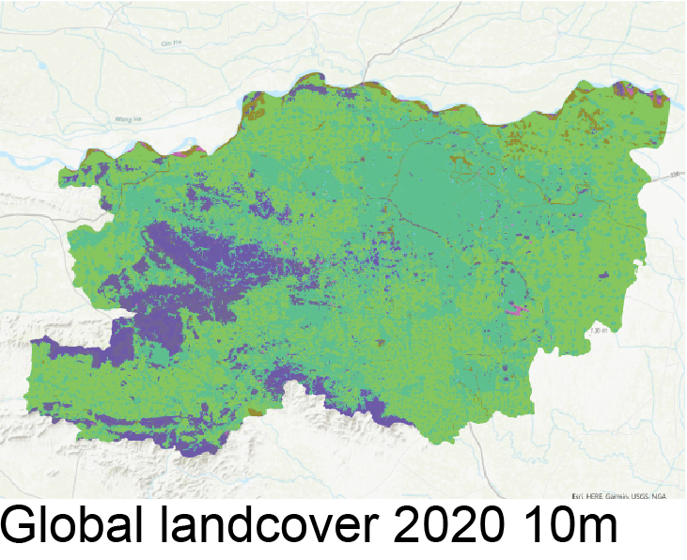 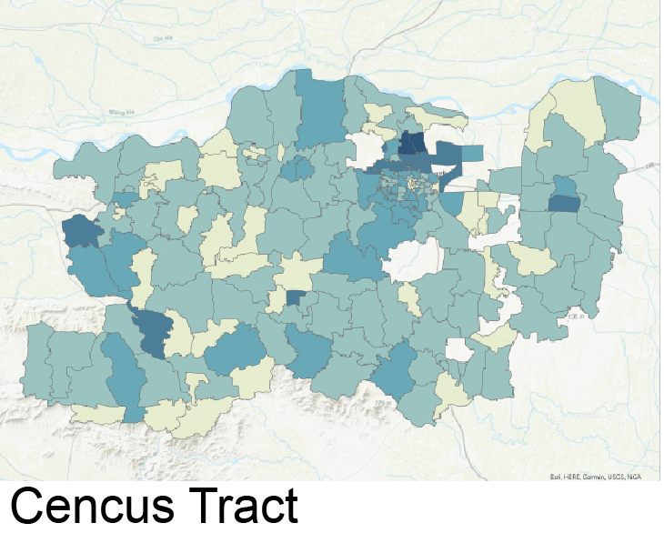 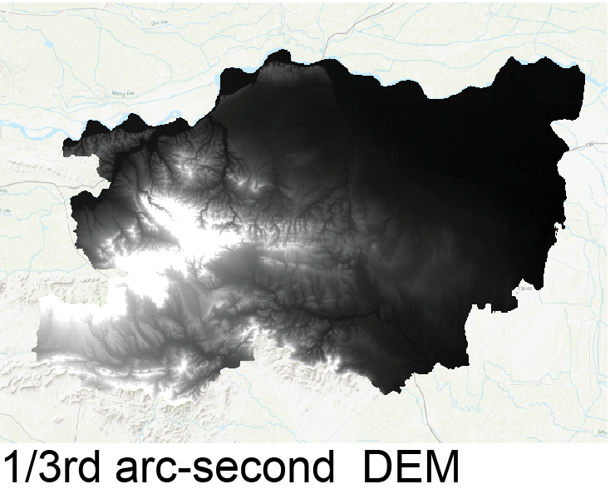 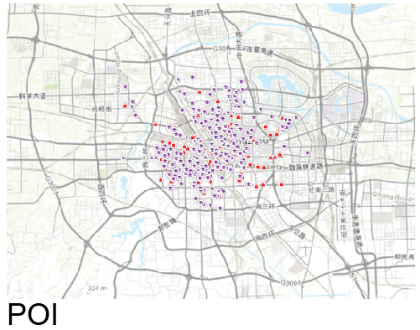

**Hydrography analysis:**

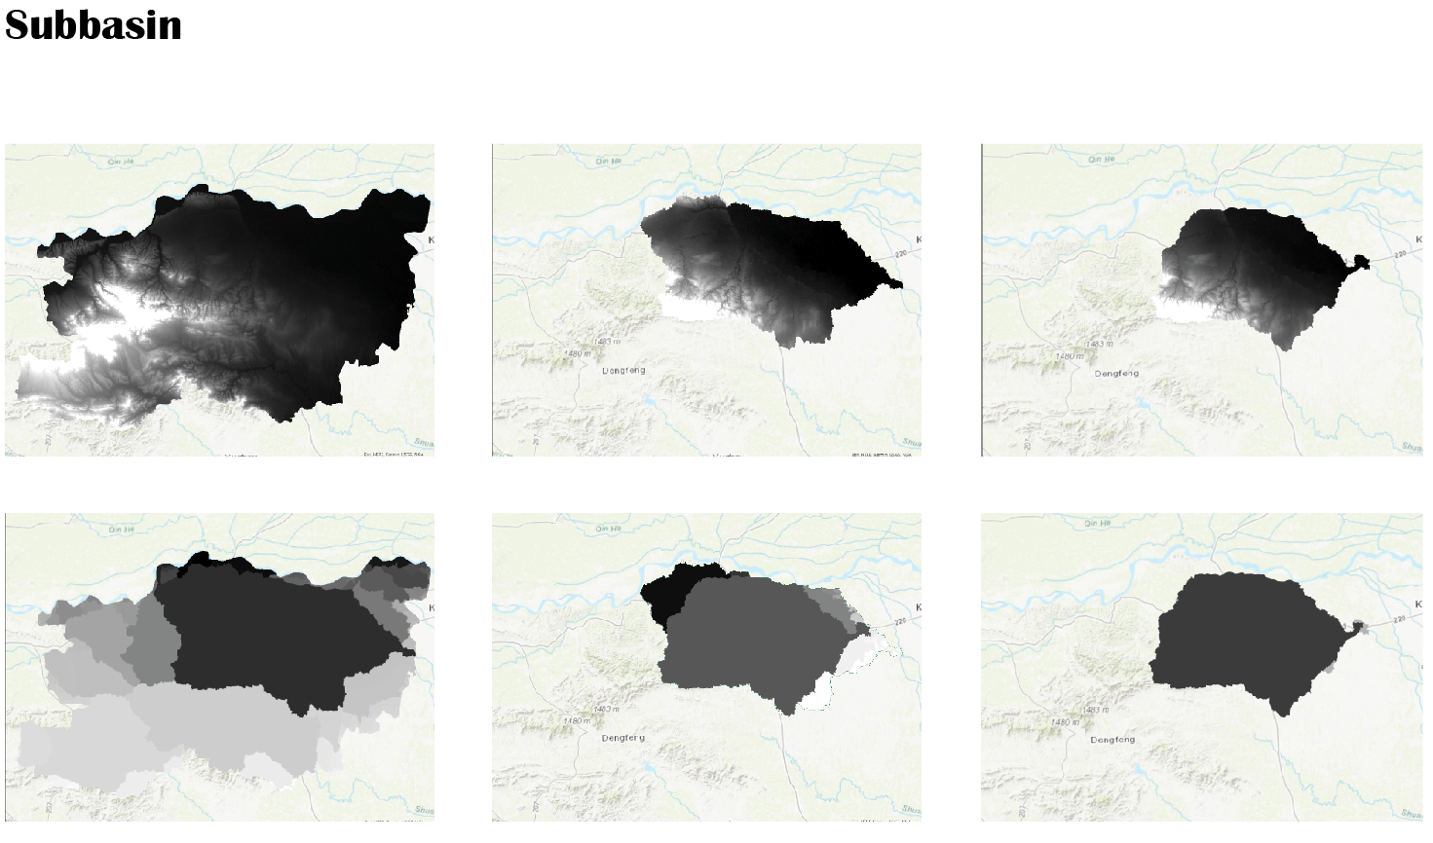

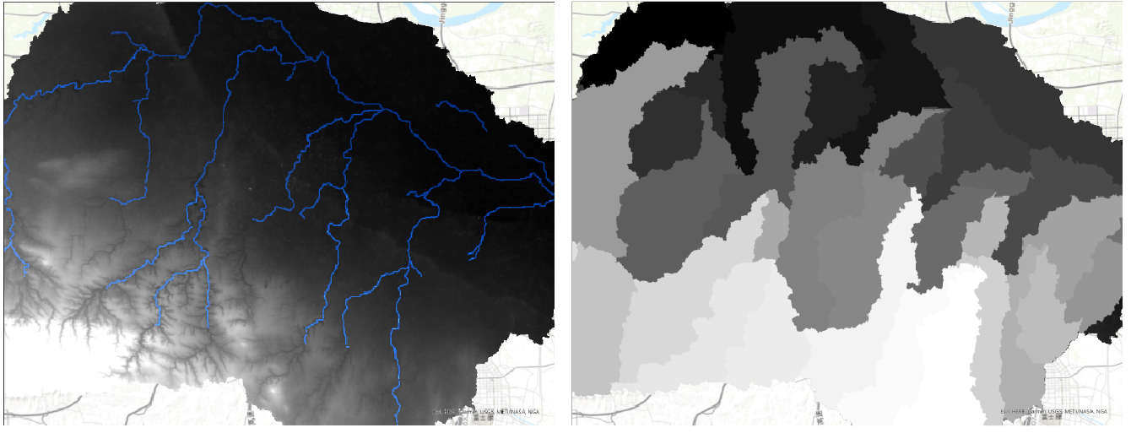City Watershed:

**Flood map Susceptibility:**

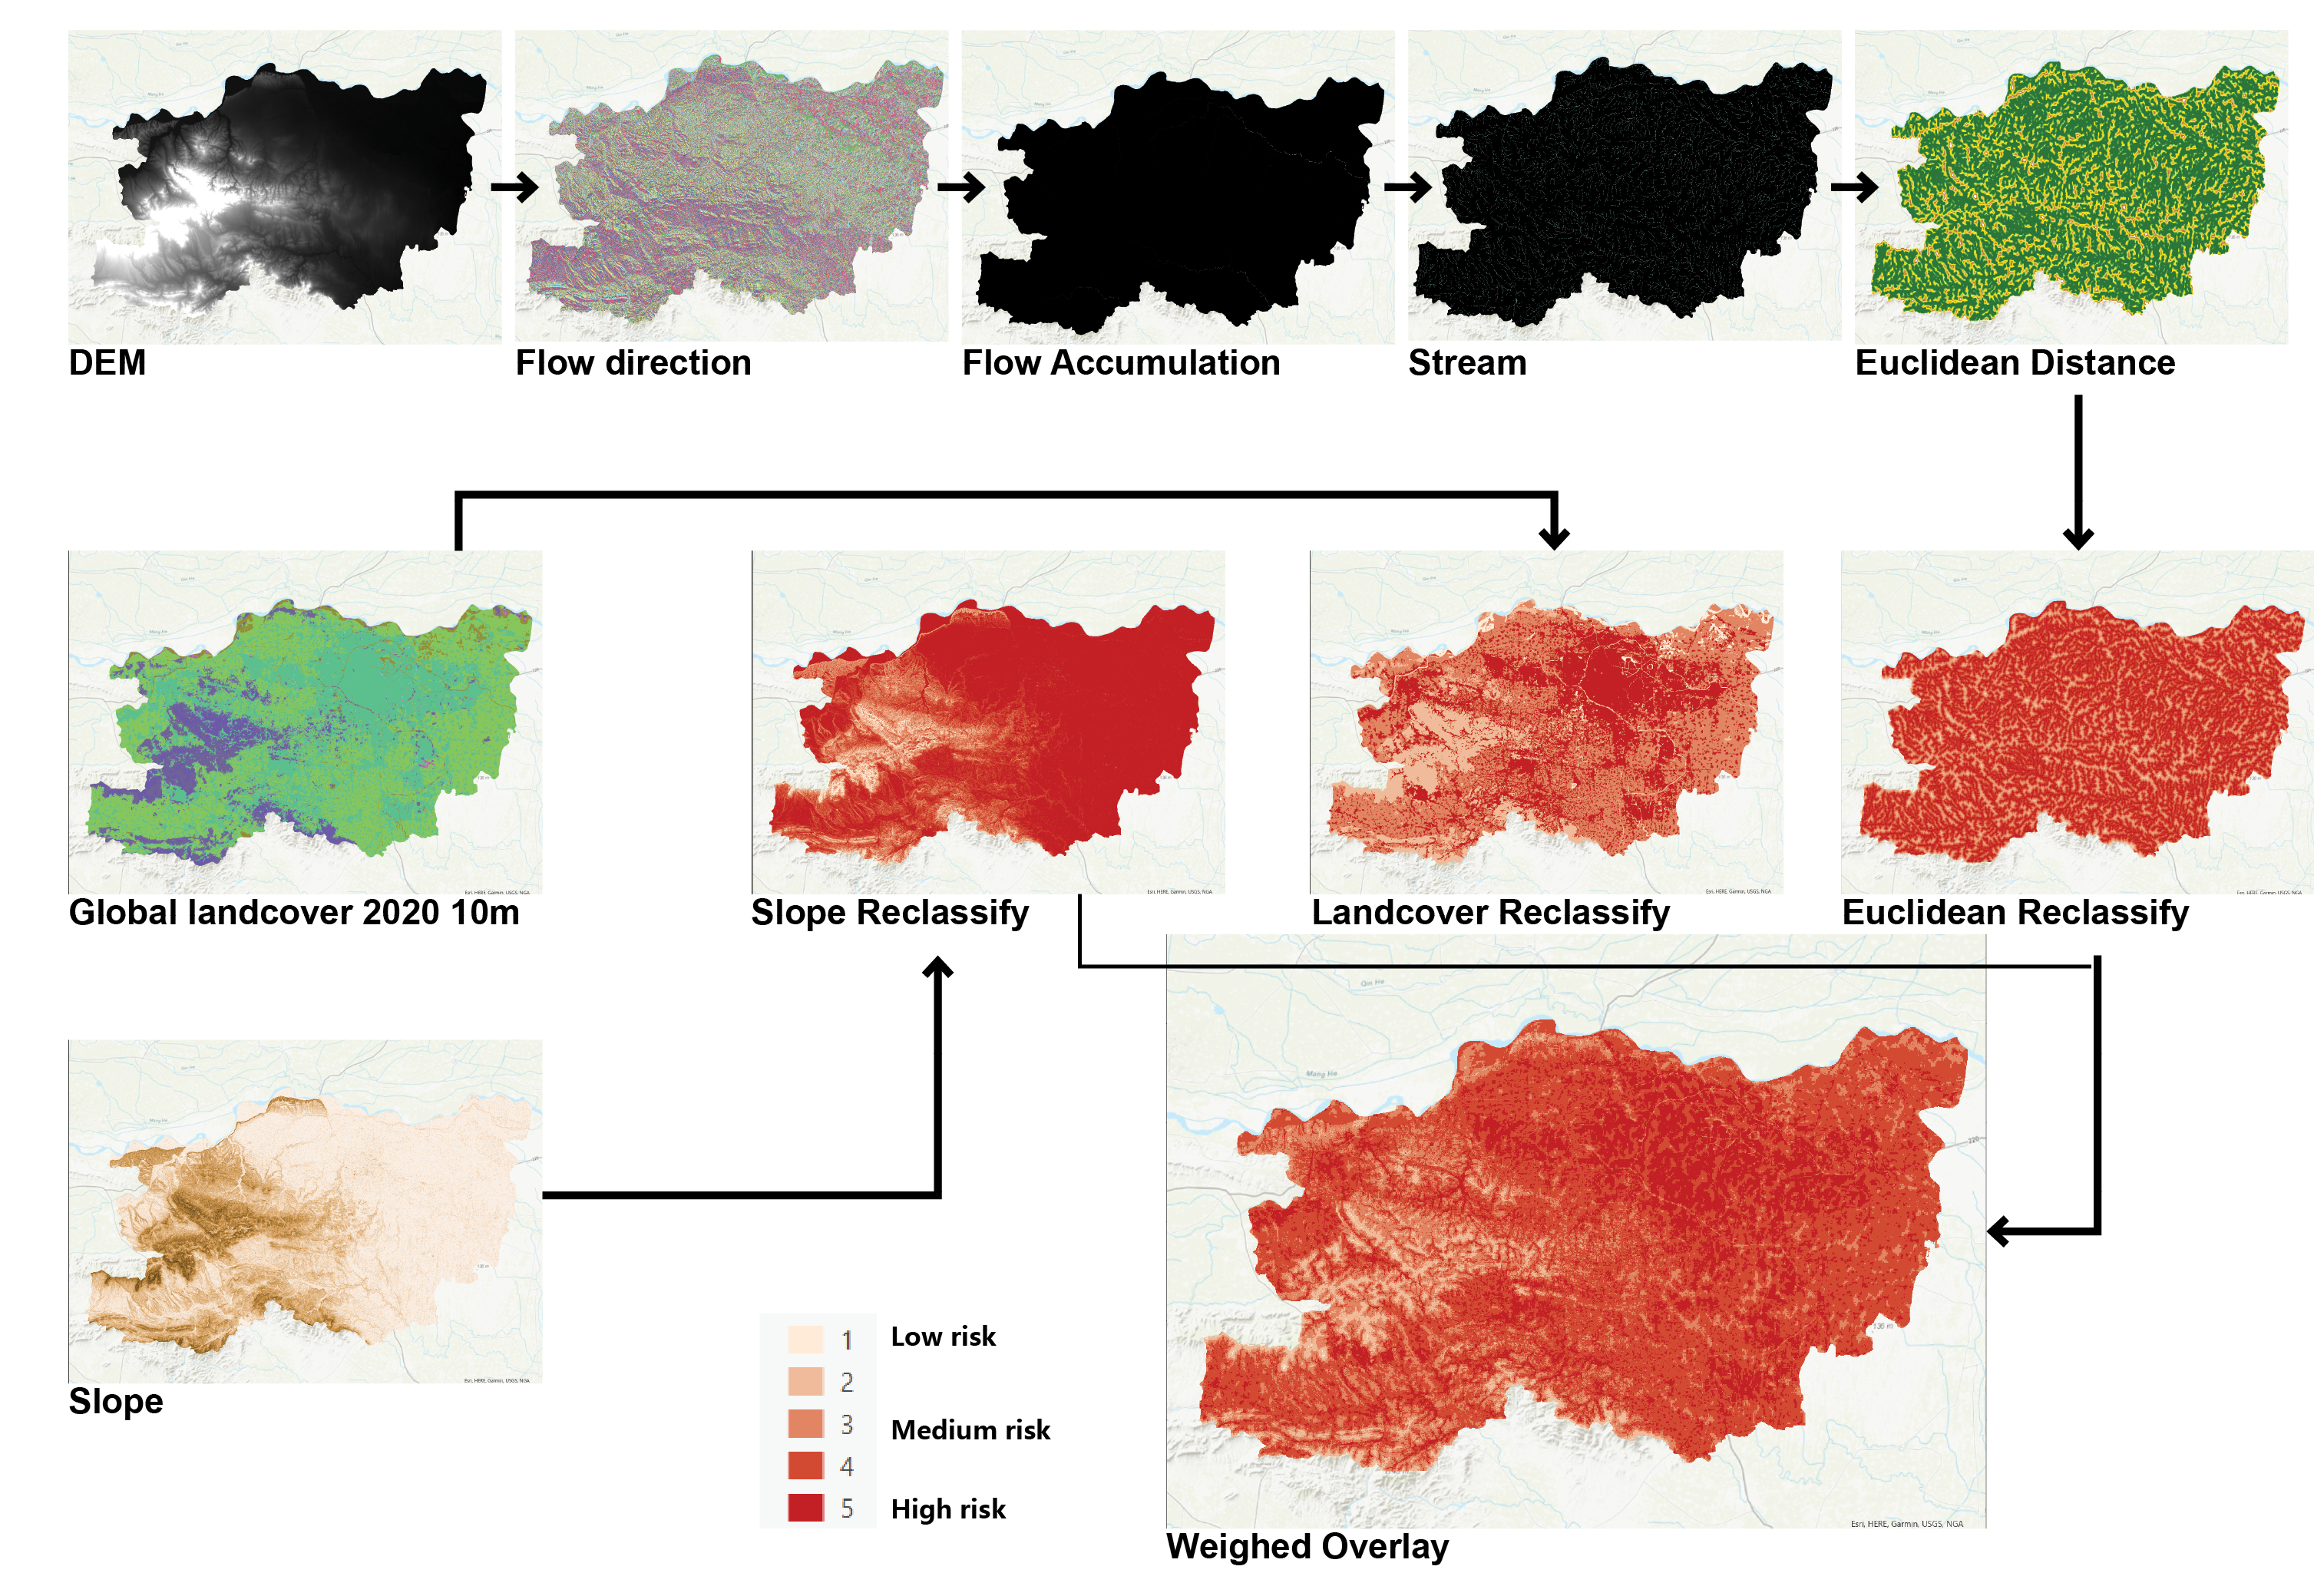

**Bluespots Defining:**

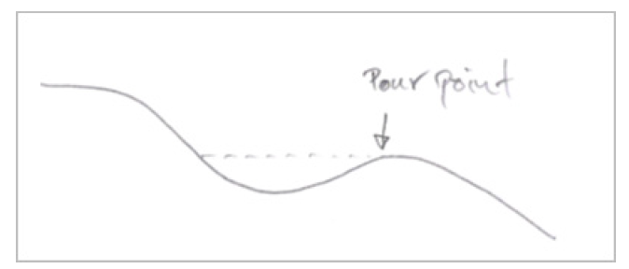

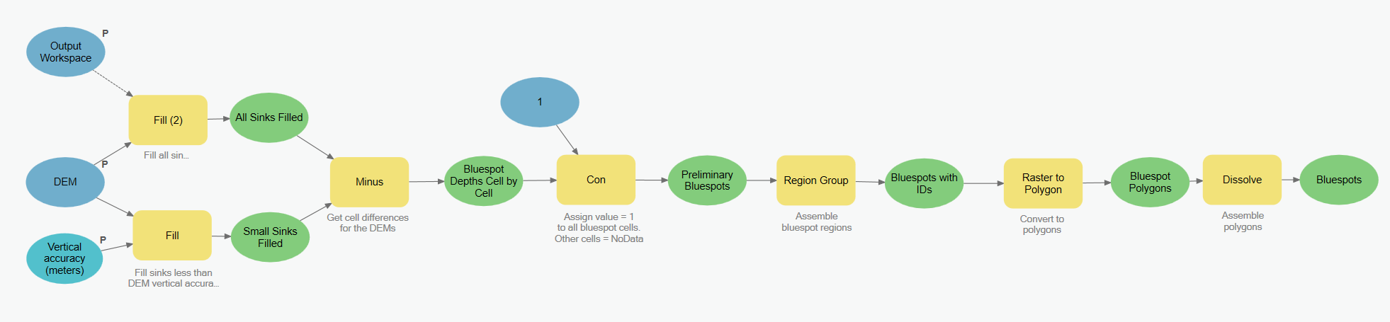

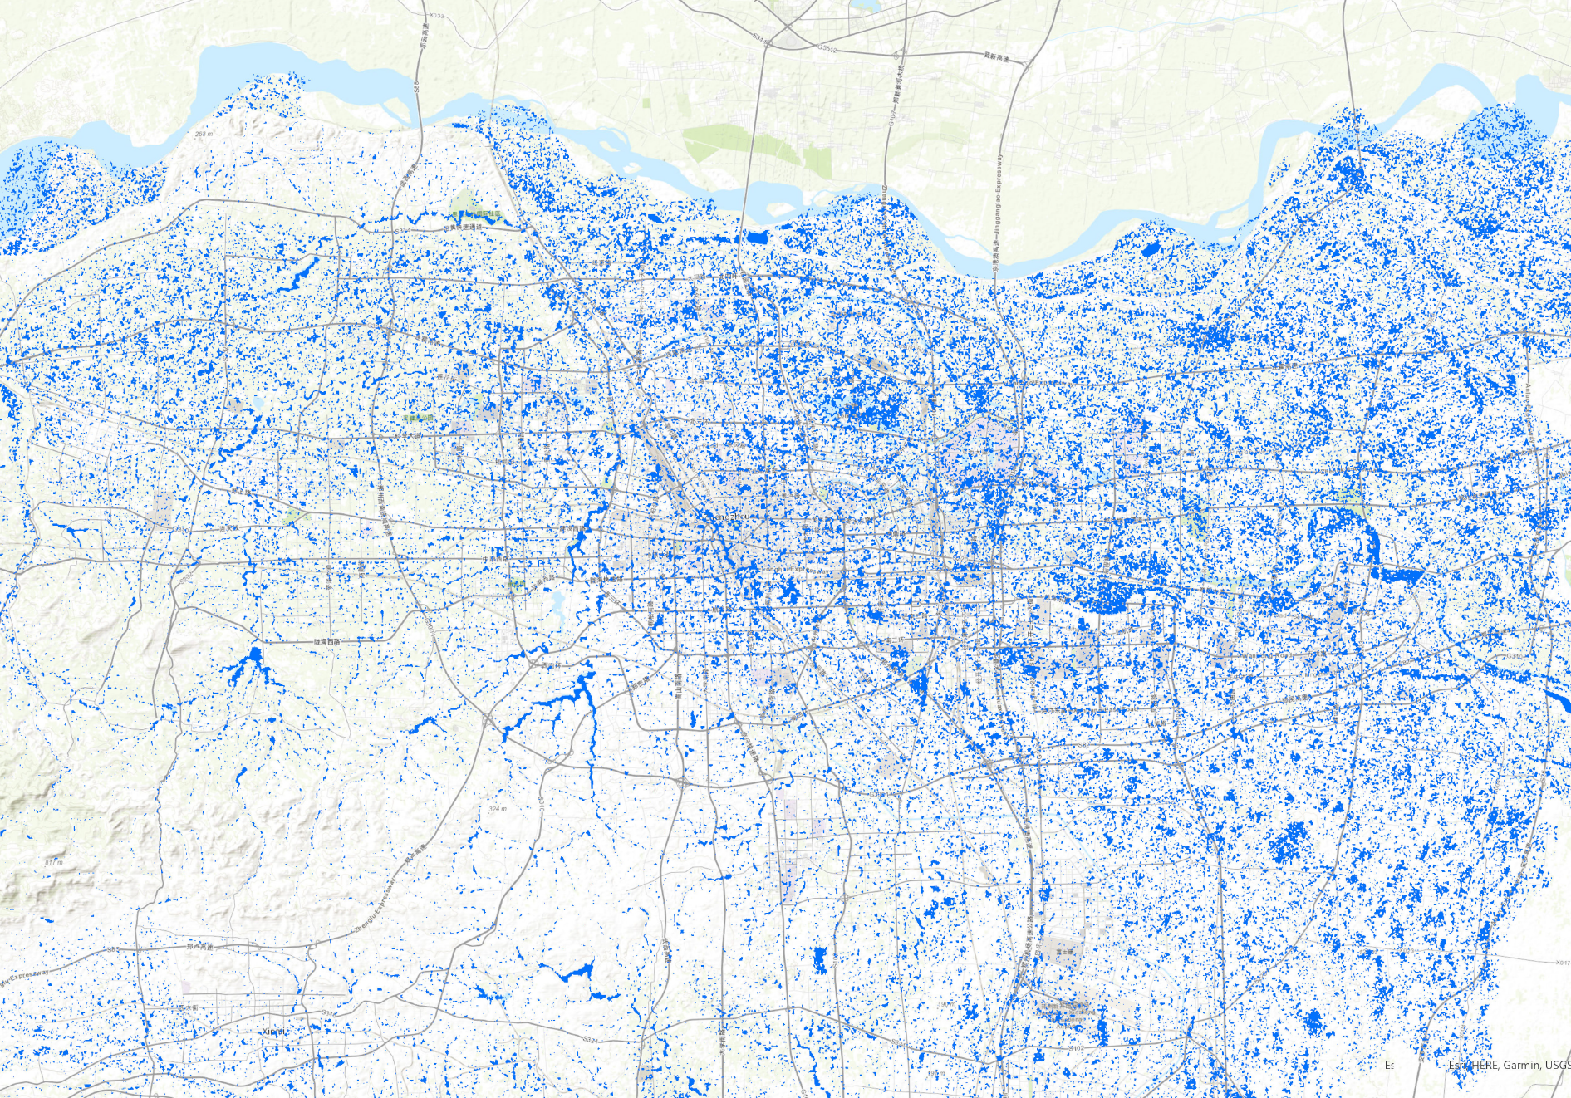

Bluespots map

**Social Indicator:**

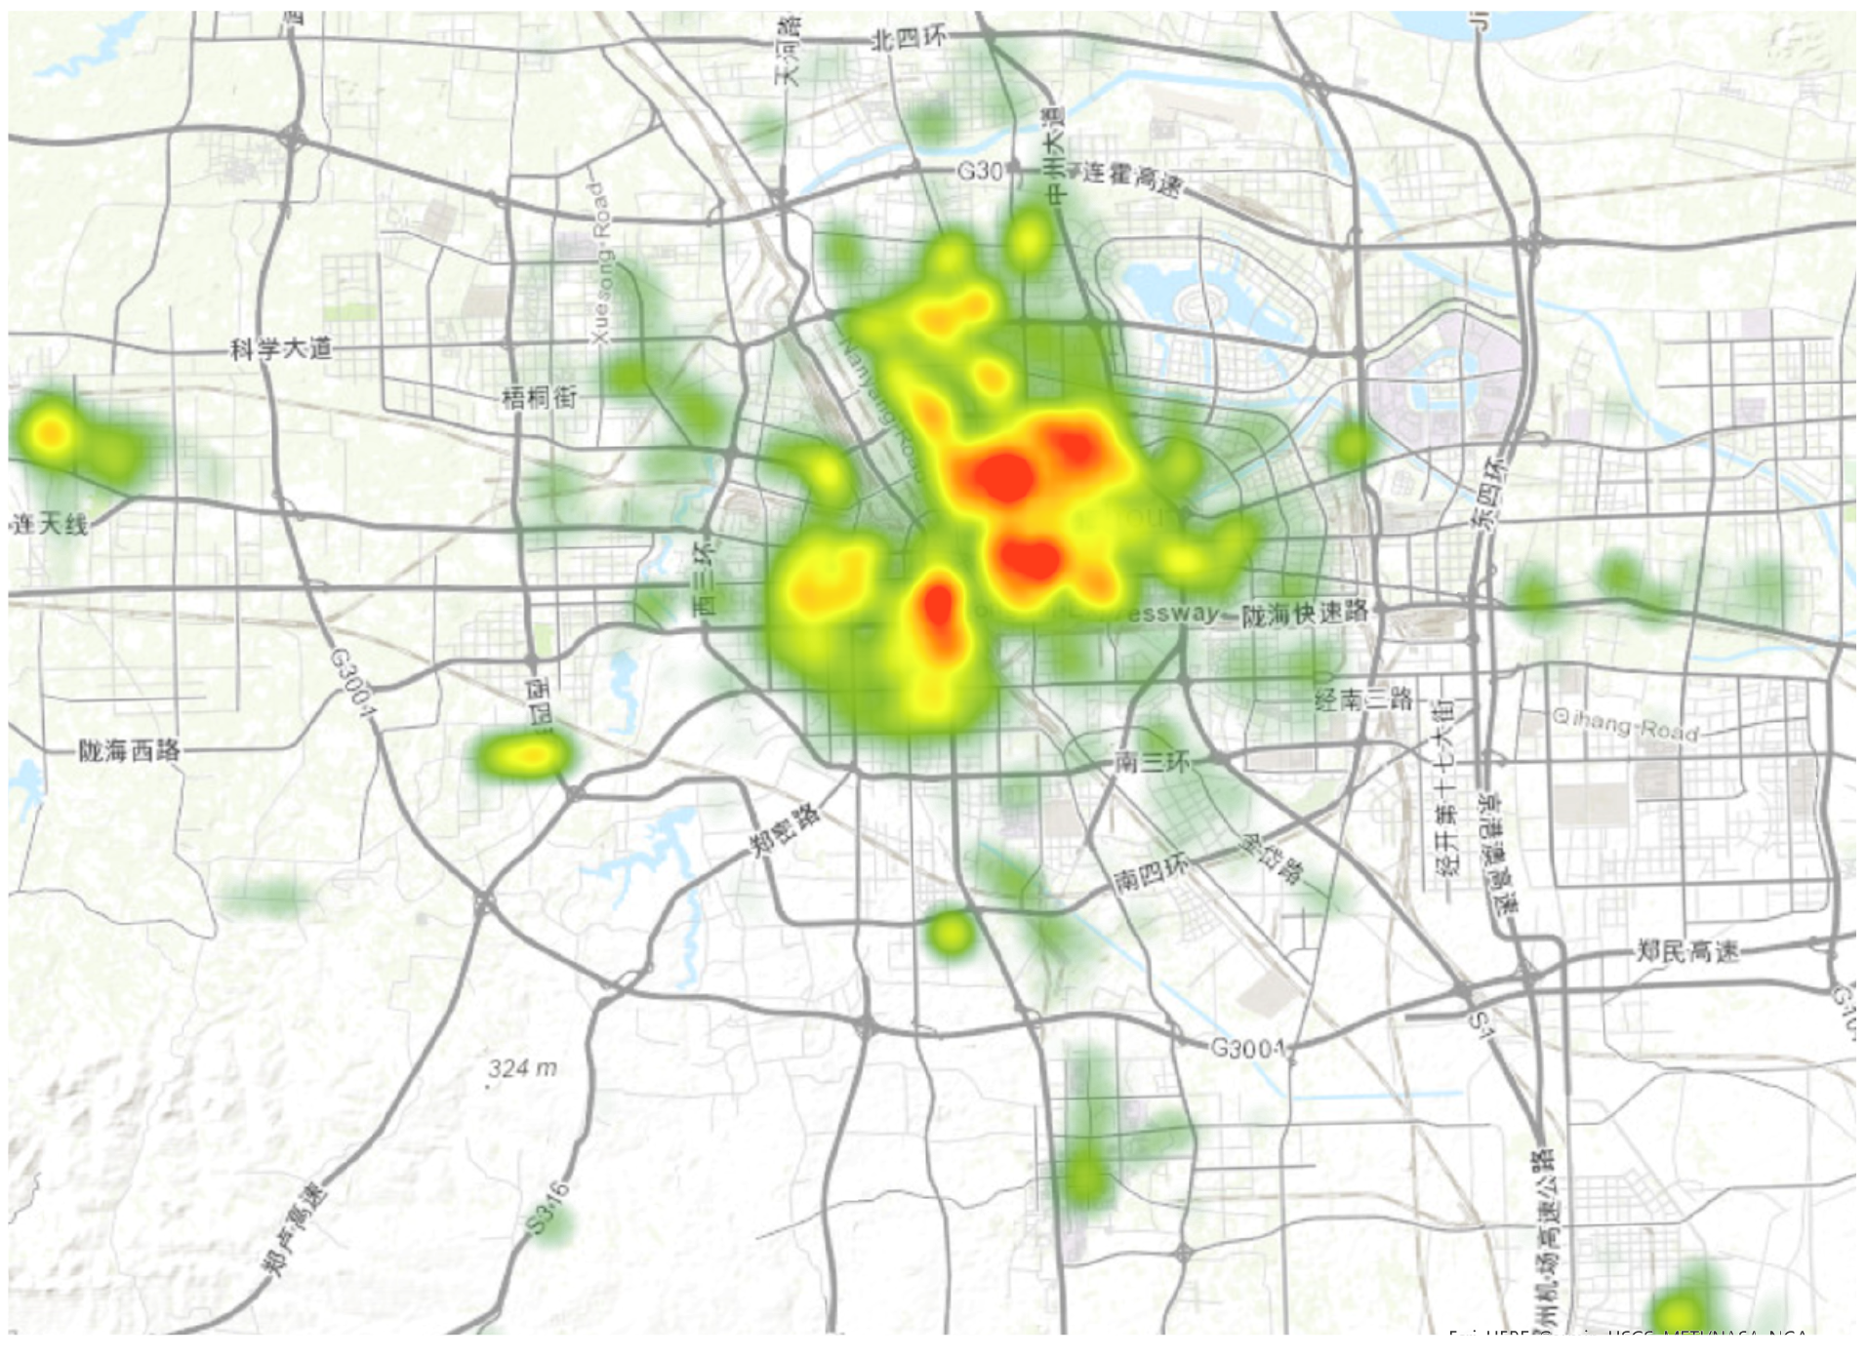 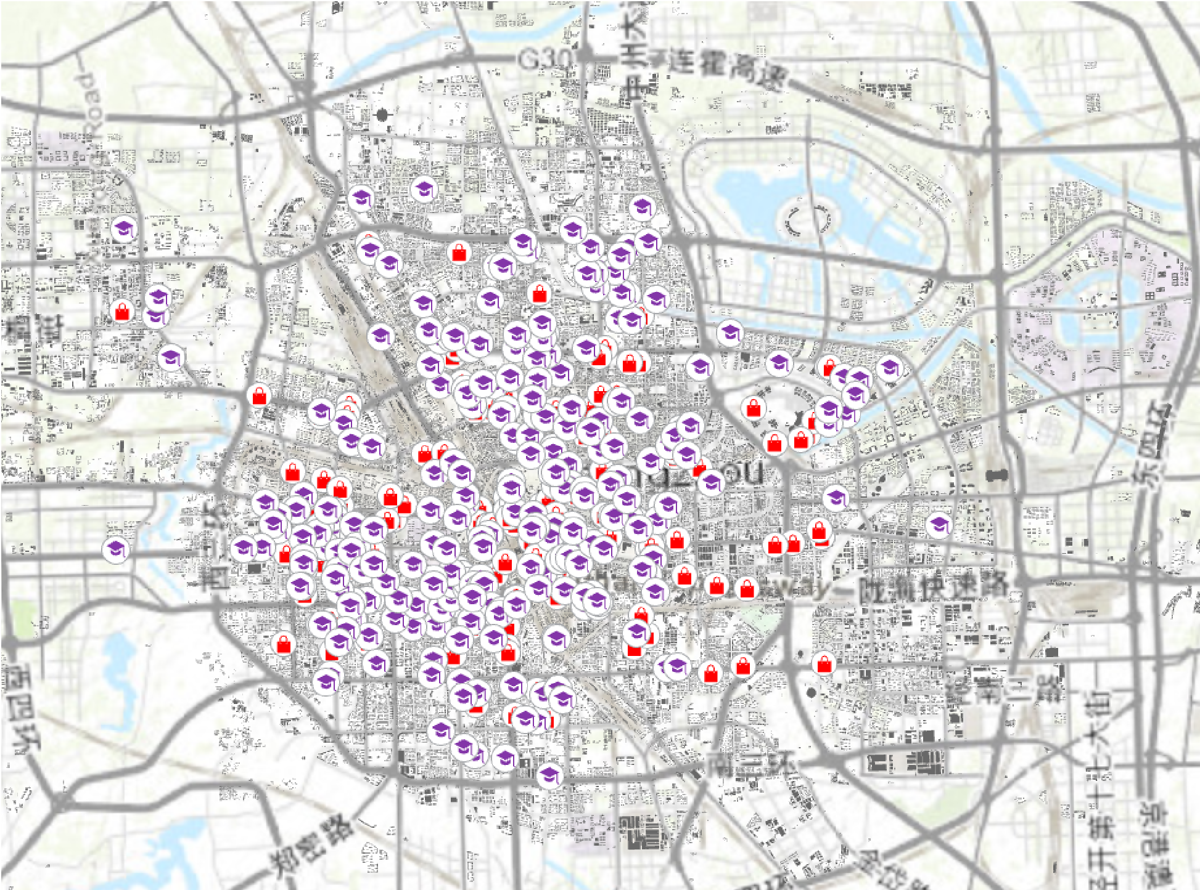 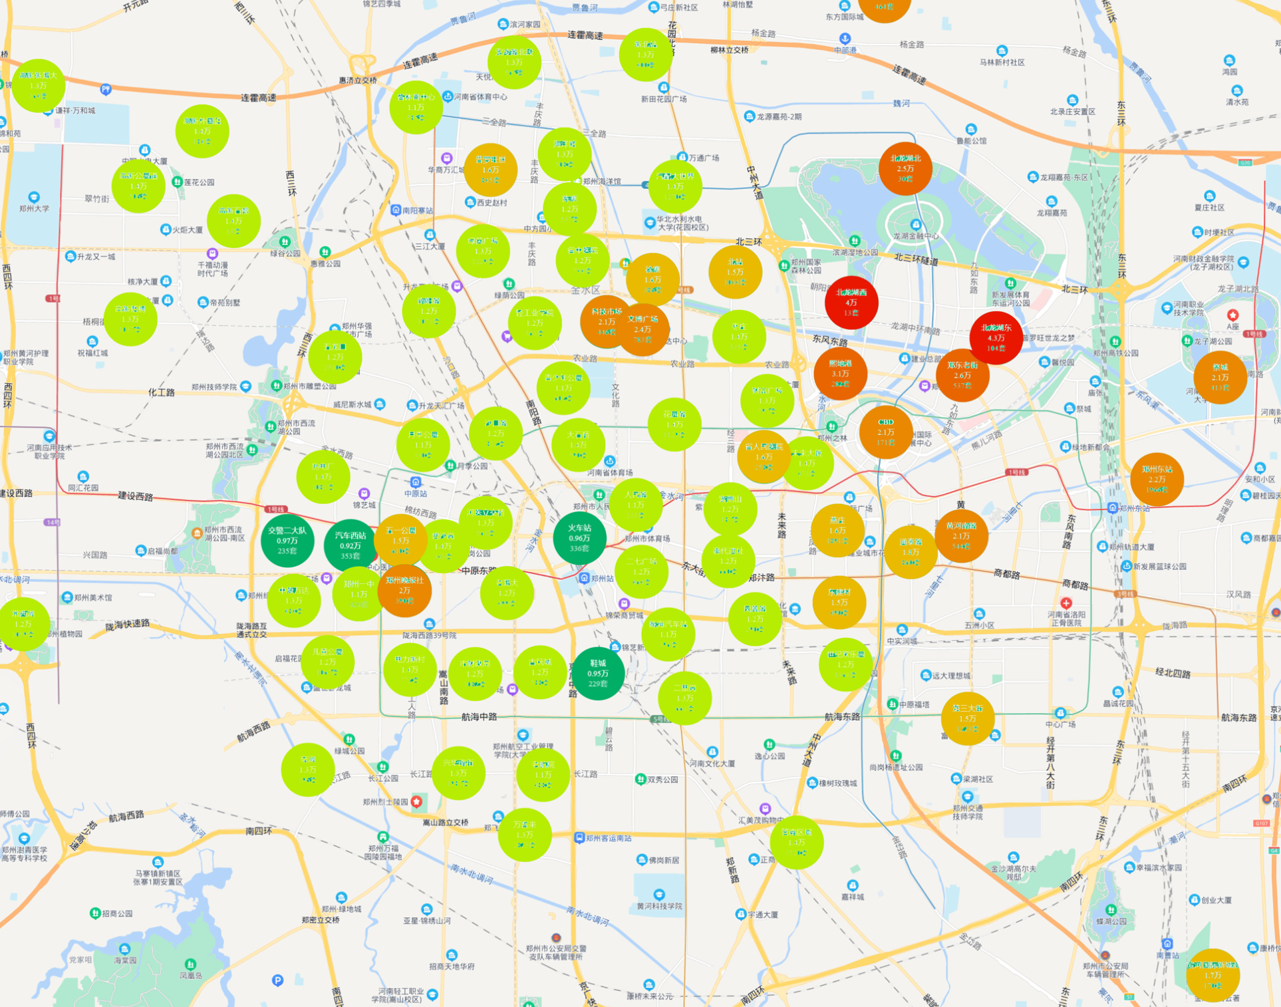

Population Density School Housing price

**SCP Facility:**

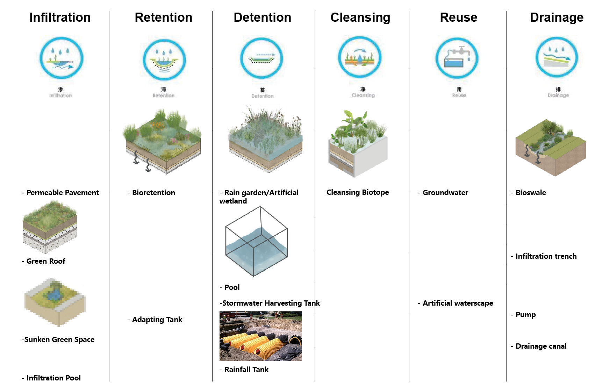

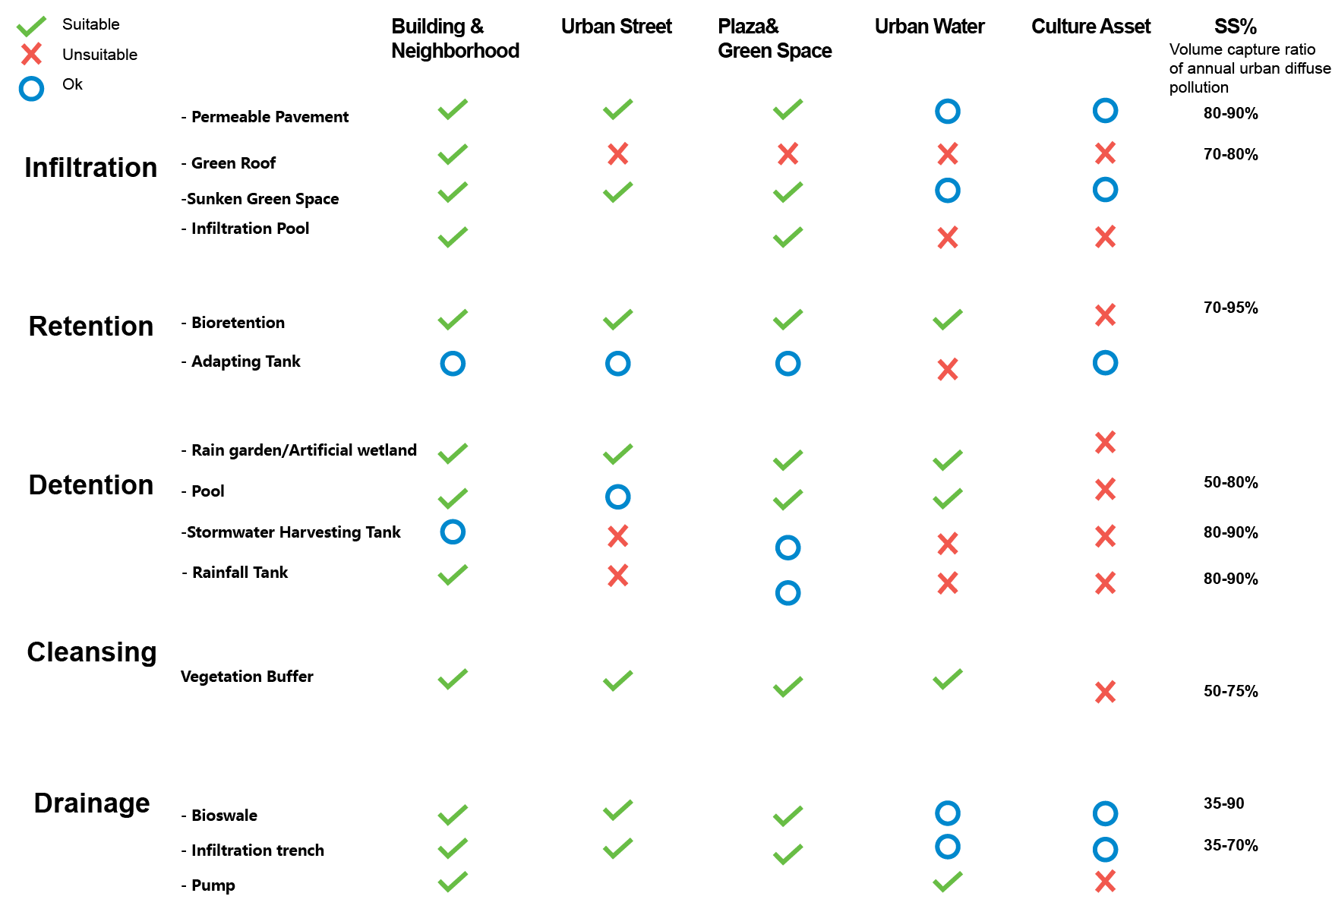

User Experience

There are two key goals when the Sponge city practice:

1. To make sure the sponge city system reaches certain design targets. **(Volume capture ratio of annual rainfall.)**
2. To select the best combination of SCPs that result in the most effective and practical management strategy possible for the location of interest.

* For planners/ decision makers

1. To prioritize the most at-risk neighborhood to have SCP intervention and adjust the funding plan.
2. Taking consideration into additional social factors, help planners to issue a more reasonable and detail planning with nuance of neighborhood.

* For DEVELOPERS & designers

The tool will provide SCP facility combinations typologies with performance indicator. It will guide developers and designers to decide the appropriate SCP combination in different social catchment area.

[1] https://en.wikipedia.org/wiki/Catchment_area